# Lab 5: Functions

## Objectives:

To understand function programming, its types and function-call.

## Tasks:

**Note: Implement all the tasks using functions.**

1. Write a program that takes marks as input and displays the grade using function.
2. Write a function minmax() that takes four integers as input and display the minimum and maximum number.
3. Write a program that prints all prime numbers between 2 and 1000 inclusive. Your program should have a function named ‘prime’ which accepts an integer and return a Boolean (a true if the number is prime and false otherwise). Display the numbers in main().
4. Given an integer number; you have to find the total number of minimum bit(s) which can be used to store given integer number. Implement the program using function. Function will take the integer as input and return the number of bits required.
5. Write a C++ function to count number of 1’s in an integer number.
6. Write a program to check the status of a particular bit of a number using function. Function will take an integer and bit number as input and return a Boolean value. Return true if bit was high, return false if the bit was low.
7. Write a program to find the roots of a quadratic equation of type a.x2+b.x+c where a is not equal to zero.

**Algorithm for function roots():**

* 1. Read the coefficients of a quadratic equation a, b, c
  2. Calculate determinant d = b*b – 4*a*c
  3. If d > 0 calculate two real roots r1 = (-b + sqrt(d)) / (2*a) and r2 = (-b + sqrt(d)) / (2*a)
  4. If d=0 then roots r1 and r2 are equal and display r1 = r2 = -b / (2*a)
  5. If d < 0 then roots are imaginary and display real root= -b /(2 * a) and img root =sqrt(-d) / (2*a)

1. Write Program to compute Sin(x) and Cos(x) using Taylor series approximation given by

Sin(x) = x - (x3/3!) + (x5/5!) - (x7/7!) + …….

Cos(x) = 1 - (x2/2!) + (x4/4!) - (x6/6!) + …….

Compare the result with the built- in Library function and print both the results.

#define PI 3.14159265

float mysin( float deg )

{

... //implement the function here

}

int main ()

{

double param, result,result2;

param = 30.0; //take it as input from user

result = sin (param*PI/180);

result2 = mysin (param*PI/180);

cout<< "The sine of " << param <<" degree using builtin function is "

<< result;

cout<<"The sine of "<<param<<"degree using user defined function is "

<< result2;

return 0;

}

Note: Use separate function for power and factorial

1. A “Perfect” number is a positive whole number that is the sum of its proper divisors (including 1 and excluding the number itself). For example, the proper divisors of 6 are 1, 2, 3 and 1 + 2 + 3 = 6. So, 6 is a perfect number. Similarly, 28 is also a perfect number.

Write a program that displays first 5 perfect numbers. The program should be composed of at least two functions additional to main function, one that accepts a number and returns a Boolean true if the number is perfect and false otherwise. The other function should display all the proper divisors of the perfect number.

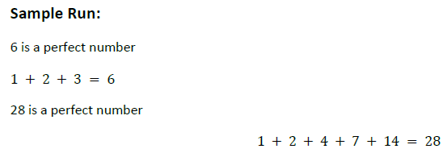

1. Write a program that displays the factorial of first N integers. Use function to find factorial.